**MODULE: 1**

**SE – Overview of IT Industry**

**Question 1 :-What is Software? What is software engineering?**

"Software is a set of programs (sequence of instructions) that allows the users to perform a well-defined function or some specified task."

Software is responsible for directing all computer-related devices and instructing them regarding what and how the task is to be performed. However, the software is made up of binary language (composed of ones and zeros), and for a programmer writing the binary code would be a slow and tedious task. Therefore, software programmers write the software program in various human-readable languages such as Java, Python, C#, etc. and later use the source code.

* **What is software engineering ?**

The software is a collection of integrated programs.

Software subsists of carefully-organized instructions and code written by developers on any of various particular computer languages.

Computer programs and related documentation such as requirements, design models and user manuals.

Engineering is the application of scientific and practical knowledge to invent, design, build, maintain, and improve frameworks, processes, etc.

Question 2 :- Explain types of software

Type Of Software

Operating System

E.g:- linux, windows etc.

Language Processor And Device Driver E.g:- Interpreter, compiler etc.

Customised Software E.g:- Railways resevation system etc.

General purpose E.g:- MS-word, Photoshop etc.

Application Software

System Software

1. **Software System**
   * Operating System
   * Language Processor
   * Device Driver
2. **Application Software**
   * General Purpose Software
   * Customize Software
   * Utility Software

**Question 3 :- What is SDLC? Explain each phase of SDLC**

A software life cycle model (also termed process model) is a pictorial and diagrammatic representation of the software life cycle. A life cycle model represents all the methods required to make a software product transit through its life cycle stages. It also captures the structure in which these methods are to be undertaken.

In other words, a life cycle model maps the various activities performed on a software product from its inception to retirement. Different life cycle models may plan the necessary development activities to phases in different ways. Thus, no element which life cycle model is followed, the essential activities are contained in all life cycle models though the action may be carried out in distinct orders in different life cycle models. During any life cycle stage, more than one activity may also be carried out.

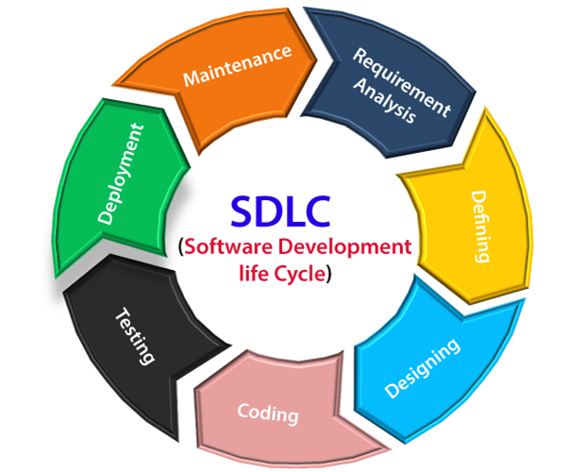

**Question 4 :- What is DFD? Create a DFD diagram on Flipkart**

A Data Flow Diagram (DFD) is a traditional visual representation of the information flows within a system. A neat and clear DFD can depict the right amount of the system requirement graphically. It can be manual, automated, or a combination of both.

It shows how data enters and leaves the system, what changes the information, and where data is stored.

The objective of a DFD is to show the scope and boundaries of a system as a whole. It may be used as a communication tool between a system analyst and any person who plays a part in the order that acts as a starting point for redesigning a system. The DFD is also called as a data flow graph or bubble chart.

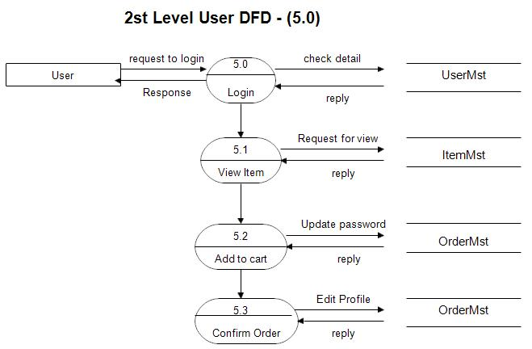

**Question 5 :- What is Flow chart? Create a flowchart to make addition of two numbers**

Flowcharts are useful tools in software development. In C programming, flowcharts are often used to represent algorithms or programs. They show the connections, flow of information, and processes within an algorithm or a program. For example, here's an if else flowchart that's often used in C programming.

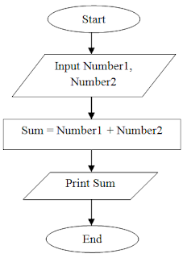

**Question 6 :- What is Use case Diagram? Create a use-case on bill payment on paytm.**

A use case diagram is a visual representation of how users interact with a system. It's a type of UML diagram that shows the dynamic behavior of a system.

